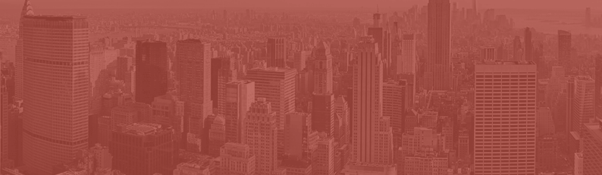
LAUREN CHEN
DIGITAL MARKETING SPECIALIST
CAREER OBJECTIVE  Digital Marketing Specialist with 4+ years of experience in online marketing, branding, and business strategy across music, media, and entertainment industries. Skilled in evaluating financial needs and implementing multi-pronged digital strategies that increase revenue and drive brand growth.  PROFESSIONAL EXPERIENCE  September 2019–Present | Triangle Music Group, New York, NY  Digital Marketing Specialist  - Manage digital sales and streaming accounts to improve brand positioning and growth  - Source and develop new strategic partnerships, social engagements, and advertising opportunities that generate new revenue streams  - Collaborate with internal departments to execute national advertising campaigns, plan global digital distribution, and re-deploy a 1M+ consumer sales and marketing database  June 2017–August 2019 | Momo Software, New York, NY  DIGITAL MARKETING ASSOCIATE  - Worked with management to develop and apply digital marketing plans with a focus on driving acquisition and conversion  - Devised and implemented robust digital acquisition plans, ensuring precision in financial reporting, budgets, and forecasts  - Increased conversions by 15% from paid sources (PPC, Grant, Display, and VOD)  - Enhanced conversion rates by 12% via A/B testing landing pages for a better performing conversion funnel  June 2016–May 2017 | Kingston Digital, New York, NY  Marketing Intern  - Helped research, write, and edit blog posts for Kingston’s website  - Determined relevant keywords and entities for pages using Semrush, Ahrefs, and Page Optimizer Pro | (212) 256-1414  lauren.chen@gmail.com  linkedin.com/in/laurenchen/  EDUCATION  May 2017  New York University,  New York, NY  Bachelor of Arts, Communications,  Honors: cum laude  (GPA: 3.6/4.0)  RELEVANT SKILLS  Digital Data Analytics  Digital Marketing  Adobe Photoshop  Adobe Illustrator  Adobe InDesign  AutoCAD  Rhinoceros  Microsoft Office  Slack

Dear Job Seeker,

One of our boldest options, the Majestic resume template emphasizes your name against a city skyline backdrop.

The attention-grabbing header is complemented by standard resume formatting that clearly outlines your qualifications. We chose a sans-serif font that’s easy on the eyes to encourage employers to read every word of your resume.

We recommend using the Majestic resume template to apply for jobs that require big-picture thinking, including consultant and business analyst positions.

If you’re still struggling to write your resume, here are some free resources to help you put together a resume that shows employers you’re the right person for the job:
· Free Resume Builder
· How to Write a Resume
· Resume Samples by Industry

Once you have a great resume, pair it with a convincing cover letter using our matching 2022 cover letter template. Here are a few resources to help you write a cover letter that gives your application the boost it needs to land you an interview:
· Cover Letter Builder
· How to Write a Cover Letter
· Cover Letter Examples by Industry

Best regards,

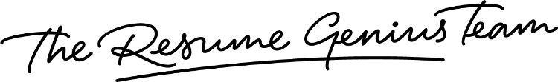

IMPORTANT: To delete the second page, right-click on the page and click “Delete Rows”

